Bryan Guner 9/18

Amath 2 Hw #1 Gibbs Sampling

* MATLAB code:

%syms x k L n

%evalin(symengine,'assume(k,Type::Integer)'); %tells matlab k is integer

%a = @(f,x,k,L) int(f\*cos(k\*pi\*x/L)/L,x,-L,L);%calculates the kth fourier cos coefficient

%b = @(f,x,k,L) int(f\*sin(k\*pi\*x/L)/L,x,-L,L);%calculates the kth fourier sin coefficient

%fs = @(f,x,n,L) a(f,x,0,L)/2 + ...

% symsum(a(f,x,k,L)\*cos(k\*pi\*x/L) + b(f,x,k,L)\*sin(k\*pi\*x/L),k,1,n);% calculates nth partial sum

%f= exp(x);

% pretty(fs(f,x,1,pi))

% pretty(fs(f,x,2,pi))

% pretty(fs(f,x,10,pi))

% pretty(fs(f,x,100,pi))

x1 = 0:0.01:pi; x2 = -pi:0.01:2\*pi;

f1 = exp(x1);

hold on; plot(x1,f1,'Color','k','LineWidth',2)

N = 100; f2 = zeros(length(x2),1);

a0=sinh(pi)/pi;

f2 = f2 + a0;

for n=1:N

f2 = f2 +((2\*sinh(pi)/pi)\*(-1)^n/(n^2+1))\*(cos(n\*x2)'-n\*sin(n\*x2)');

if(n == 1 || n==2 ||n==10||n==N)

plot(x2,f2,'--','LineWidth',1)

end

end

legend('f(x)','N=1','N=2','N=10','N=100')

xlim([-pi 2\*pi])

ylim([-4 20])

title('Gibbs sampling')

xlabel('x axis ')

ylabel('f(x) & Sn(x)')

grid

* Plot:

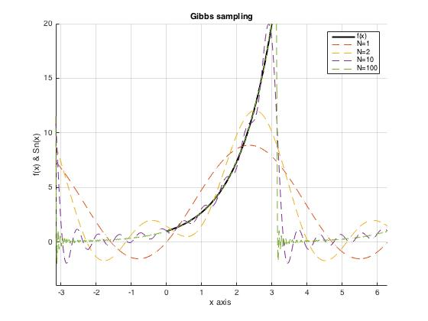

* Explanation:

The Gibbs Phenomenon can be observed most clearly near the left and right limits of points of discontinuity of the function on a given interval. In the case of the function f=e ^x from –pi<x<pi these points appear at multiples of pi on the x axis.